Project Report

Abstract

White blood cells (also called leukocytes) play an indispensable role in protecting the body from infections of disease and foreign invaders. In modern blood test, the number of White Blood Cells (WBC) will be included with specification to the number of each cell type, which offers us a glimpse into our body immune system and any potential risk we are facing. Thanks to the development of microscopy, we are able to capture the actual image of different kind of white blood cell. In order to further understand the mechanism of our body immune system, we need to look deeper into the morphology and distribution of white cells based on the information provided by image.

Therefore, after investigating various kinds of model and method, we used convolutional neural network model to design an automated model with the ability of categorizing leukocytes so that physicians and scientists may have more time on medical care and research. As the result, we have achieved the test accuracy score of____, which is fairly good in predicting the specific kind of leukocytes from four classes.

1 Introduction

In this project, we are aimed to categorize four major kinds of leukocytes. The first one is Neutrophil, which composed of almost 50% of all leukocytes. Neutrophil is also the first cell that foreign invaders will encounter after them enter the human body; it is expected to release chemical signal as a messenger to inform other leukocytes. Morphologically, the neutrophil has nuclei and the nuclei are segmented by chromatin connected by filaments. Then comes with the Eosinophils, which only composed of less than 1% of all leukocytes but are important in fighting with invaders especially the parasites. They are usually aggregated in intestinal tract and other digestive system, and may cause some allergic symptom when high in concentration. Eosinophil granule are usually orange, and its nuclei is shorter and less segmented than that of neutrophil. The third one is Monocytes, which composed of 5% of leukocytes. They are known as scavenger in human body, hovering around the body and cleaning dead tissue or cells. The chromatin of Monocytes is not as dense as that of neutrophil, and they are large in size, but their size and shapes vary a lot, making them hard to discern. The last, but also maybe the best-known leukocyte is lymphocyte, which can be divided into T lymphocyte and B lymphocyte. The function of T cell is to kill the foreign invaders through the process of phagocytosis; B lymphocytes is widely used in producing vaccine, because it is able to produce antibodies to remember specific type of bacterial or virus, thus responsible for humoral immunity. Lymphocytes are usually small in size, and has nuclei with very dense and smooth chromatin and small rim of light blue cytoplasm. Below are typical examples of cell images from these four types:

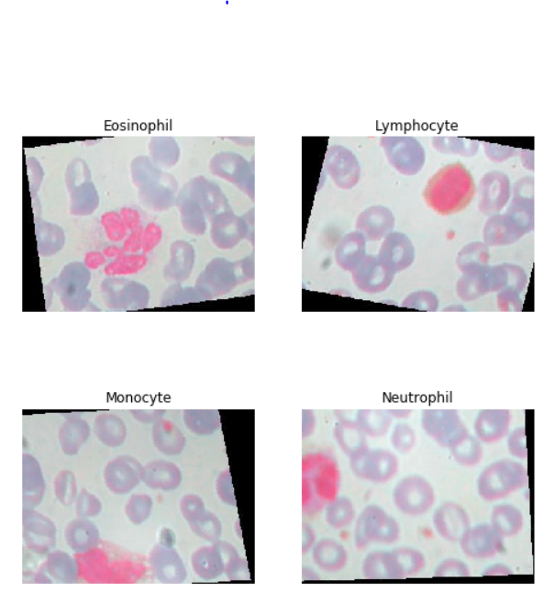

Example cell images

Therefore, based on the differences of morphology of leukocytes, we believe that the convolutional neural network model is able to recognize different types of leukocytes based on their morphological features in the image.

2 Methods

2.1 Data overview and preprocess

The data we use is from an openly available Kaggle data set about blood cell images. There are about 12500 pictures containing four kinds of leukocytes and the size of each image is 320*240 with standard RGB channel. The original dataset is divided into 4 folders, each stand for a different cell type, for both train and test data.

By first checking the image data, we found that there are some duplicate pictures in these files (different files from different classes but with the same name), so we decided to merge all images only into 2 folders: train and test, and delete images with duplicate names. The reason we do this is that we would like to split the whole training dataset into 80% training and 20% validation data and use image generator to output image batches, rather than read whole dataset into memory, which is adopted by original kernel.

Besides, since we no longer split images into 4 folders to stand for their class, we created two csv files to document the image name and its label for reference. We use numerical labels to represent cell types, which is shown below:

1: Neutrophil

2: Eosinophil

3: Monocyte

4: Lymphocyte

The program of this part is in Data Cleaning.ipynb.

2.2 Image generator

As mentioned above, the data set contains 12500 320*240 images. If we directly load them into the computer memory without resize, it is very likely that there will be a memory exhaust problem. But resize, as a compromise alternative, also impairs the amount of information an image can provide. Therefore, we decide to use an image generator that read images directly from hard drive during the training process so that we can use full size images without causing memory exhausting.

After reading the image, the generator will also do some pre-processing to improve the efficiency and robustness of the model. First, it will normalize the image and divide it by 255, which allows the network to more quickly learn the optimal parameters for each input node. Then it will augment the image from training dataset by rotating or flipping them with a random parameter. This has the same effect as providing more training data and it will provide better robustness and generalization ability to our model.

In the result evaluation part, we will try different batch size and resize scale to test whether it will influence the final performance of the network.

2.3 Model selection

To construct deep neural network, we consider using Conv2D, dense, max-pooling, dropout, flatten and batch normalization, with ReLU as our activation function and Adam optimizer due to their superior performance. We start with applying pretrained model from image net because it has already been trained on a large amount of data so that it can serve as a perfect base for our model. Then we pass the output of pretrained model into a 2-dimension convolution layer. Then, we use batch normalization to reduce the covariance shift. We also insert a max pooling layer to reduce the spatial dimension. After that, a dropout layer is applied to output so that it will lose certain percent of units. And we flatten the result and apply a dense layer with softmax function to pick up the result with maximum likelihood. The structure of our model is shown below:

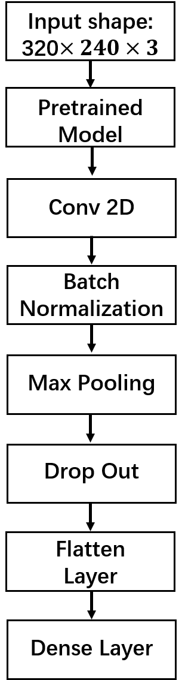

Pretrained model

Pretrained model is a model that has been trained on some kind of data. Although it may not perform well on a specific task, it can be a good corner stone for a model that is aimed for a similar task. In our case, we want to classify the leukocytes, which is a task that can be categorized into general image classification. Therefore, using a model pre-trained on millions of images as a base model will be a better choice rather than training a new model from scratches.

Below is a list of image classification model provided by Keras. In this case, we use InceptionResNetV2 as our pretrained model because it has very good validation accuracy and the deepest net structure, which means that it is highly optimized for general use.

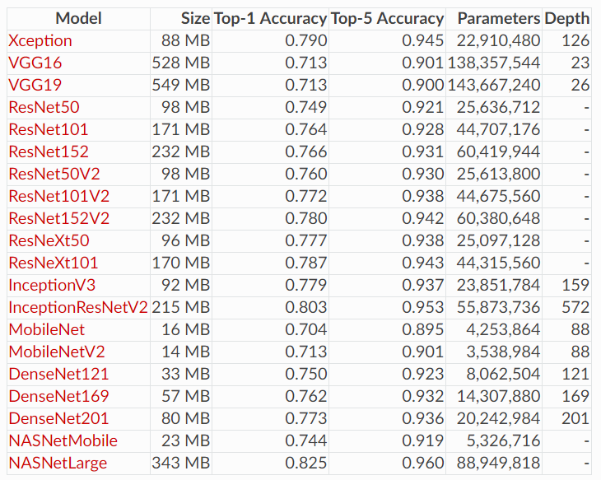

Convolutional Network

Convolution network is used to extract features from 2-D images. The basic principle behind it is to apply filters on the matrix to achieve a certain image processing like blur or edge detection. This process is called hierarchical feature learning, which is similar to how brain identifies the objects. Thanks to the existing libraries, we are not required to produce filters by ourselves but only to decide the number and size of filters. There is a figure below displaying the function of convolution layer. The extracted features will later be used to calculate the weights for each neuron.

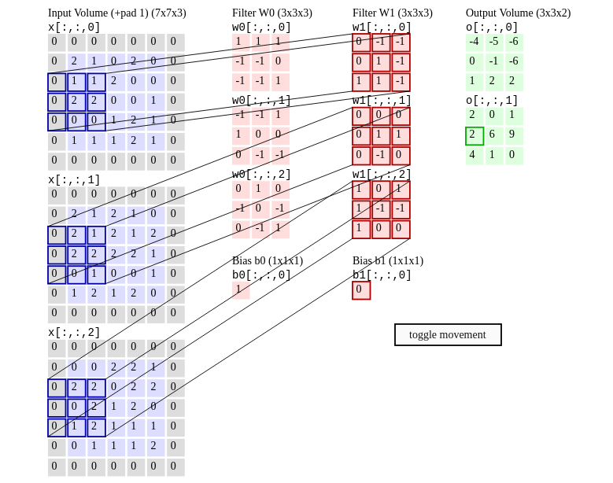

Batch Normalization

Generally, what normalization do is to adjust and scale the input from a much larger range to [0,1]. The reason why we need this normalization layer is that by normalizing the inputs, the amount by what the hidden unit values shift around will reduce, which means less time for the model to reach the optimal parameter.

Batch normalization can also help the model to increase resistance for overfitting because it has a slight regularization effect.

Max Pooling

Max pooling is a sample-based discretization process. It helps to down sample the input representation and at the same time reduce the dimensionality. By doing so, max pooling layer not only lower the computational cost but also increase the resistance of model against overfitting. Besides, max pooling also provides basic translation invariance to the internal representation, which helps to improve the robustness of the network.

2.4 Regularization and Optimization

Adaptive learning rate

Learning rate is one of the most important hyperparameter for the network training since it has great influence on the model performance. It is hard to tune a fixed learning rate since when it is too small, it will take a long time to get the optimal model parameters, while when it is too large, the model parameters may be stuck at a local minimum. Therefore, it is advised to use adaptive learning rate during training process. To be specific, the loss will be monitored during training and if the model performance doesn’t improve for some epochs, the learning rate will be lowered.

Early stop

If a model is trained on a small set of data, it is often the case that the model will overfit and doesn’t perform well on test data, because the model will adopt some noise features from training data and apply them to predict the result. Overfitting is represented as a huge gap between training loss and validation loss. Early stop is a strategy that stops model training when the monitored validation loss or accuracy doesn’t improve anymore. It serves as a great method against overfitting.

Drop out

Drop out is another regularizing method that randomly sets a fraction of input units to 0 in order to prevent overfitting. The reason why this works is that it helps the model to reduce the dependencies on a certain unit. Generally, the drop out lay is used after the max pooling layer as well as on the fully connected layer.

3 Result

Based on this model structure above, we build a neural network model that achieves at best 88.32% test accuracy on this four-class classification task. The loss and accuracy curve are shown below:

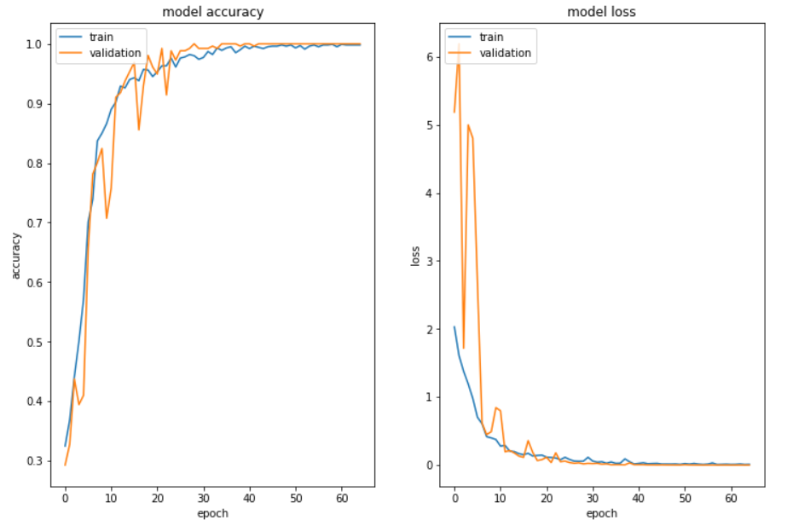

It is noticeable in the results that at the end of training, the validation accuracy is almost 1. This is due to the fact that the training dataset is augmented from the same original dataset (The original dataset containing 410 pictures is split into training and test data and augmented to 12500 images) and they may share similar features. So in this case, validation loss is not very good criterion for our model performance.

As comparison, below lists two kernels on the same dataset with their performance:

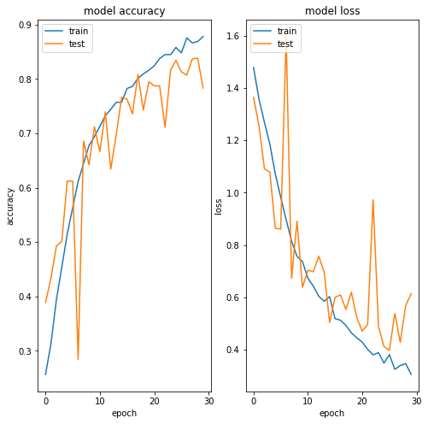

Paul Mooney’s kernel reaches the test accuracy of 78.32%. It resizes the image to (60,80,3) and the model doesn’t include a pretrained model layer.

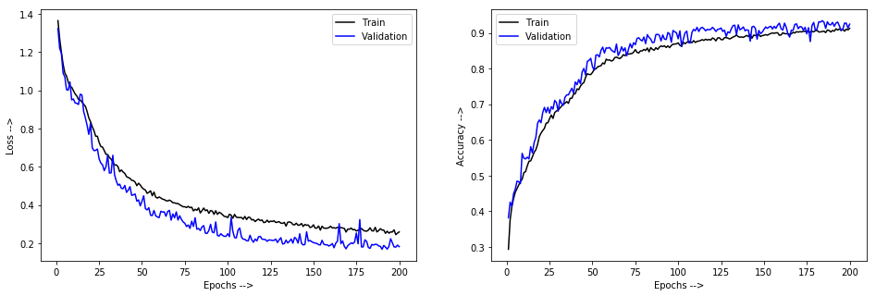

nh4cl’s kernel reaches the test accuracy of 83.76%. Compared to Mooney’s kernel, it increases the depth of model with more layers and adopts image normalization before training.

In my opinions, our model surpasses their model performance mainly because we use a pretrained model and the full-size images to train the network.

4 Discussion

Batch size decides upon the quality of every parameter update. The larger the batch size is, the better an update will be in improving model performance. However, considering the memory constrain of GPU, there will be a limit on the maximal number of images per batch. Sometimes, we have to resize pictures so the model can be trained on a larger batch size. But it also reduces the information provided by each picture.

To balance between these two hyperparameters, we try using different image size and batch size to see its influence on the model performance. The result is shown below:

|  |  |  |
| --- | --- | --- |
| Image size | Batch size | Test accuracy |
| (240,320,3) | 20 | 88.32% |
| (150,200,3) | 50 | 83.84% |
| (90,120,3) | 100 | 77.18% |

Based on the result, we can see that test accuracy is more concerned with image size rather than batch size. Therefore, in our final model, we use the full-size images as our input.

Besides, we also plot the confusion matrix to see the model performance on predicting images from a certain class. The result is shown below:

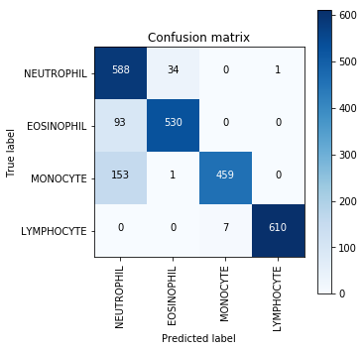

It is noticeable that many eosinophil and monocyte are predicted as neutrophil. It may be due to the fact that in the original dataset, the neutrophil takes the most part (about 50%) and when the classifier is not so sure about the prediction, it will predict its label as neutrophil. Another interesting fact is that monocyte is the class on which the model performs worst. As mentioned in the introduction part, monocyte is the cell type being most difficult to discern among all leukocytes, and this is supported by our prediction result.

5 Conclusion

In this project, we designed a leukocyte classifier based on neural network that is able to categorize among neutrophil, eosinophil, monocyte and lymphocyte micrographs. And our final model reaches a test accuracy of 88.32%, which is much better than the baseline: 25%. Compared with other kernels, our model also performs better mostly because we adopted a more complex structure and full-size images as our input. Based on the positive outcome achieved, the model may serve as an auto classifier for different leukocytes so that the physicians and scientists will have more on research and medical care. In the future, we proposed to test the model on a huge amount of data and improved it into a classifier that can be applied on images containing more than one kind of white blood cells.

Reference

Adrian Rosebrock, Keras Conv2D and Convolutional Layers, Dec 31, 2018

[Firdaouss Doukkali](https://towardsdatascience.com/@phidaouss), Batch normalization in Neural Networks, Oct 20, 2017

SuperDataScience Team, Convolutional Neural Network (CNN): step2: Max-Pooling, Aug 17, 2018

Lan Goodfellow, Yoshua Bengio and Aaron Courville, Deep learning, 2016

[Lynne Eldridge,](https://www.verywellhealth.com/lynne-eldridge-md-2248383) Types and Function of White Blood Cells (WBCs), Mar 12, 2019

Alex Alemi, Improving Inception and Image Classification in TensorFlow, Aug 31, 2016